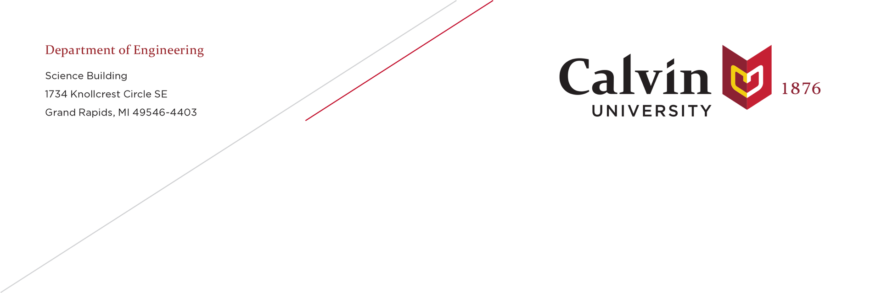30 September 2025

Dear Editors:

My co-authors and I are pleased to submit an original research article to *Energies*.

*TITLE*

The Exergy of Materials with Application to Societal Exergy Analysis

# *AUTHORS*

Erin Schuman1, Sofie Schumerth1, Matthew Kuperus Heun1,2,3*, and Tânia Sousa4

1 Engineering Department, Calvin University, 3201 Burton St. SE, Grand Rapids, MI, USA, 49546

2 Sustainability Research Institute, School of Earth and Environment, University of Leeds, Leeds LS2 9JT, United Kingdom

3 School for Public Leadership, Faculty of Economic and Management Science, Stellenbosch University, Private Bag X1, Matieland, 7602, Stellenbosch, South Africa

d MARTEC—Marine, Environment and Technology Center, LARSyS, Instituto Superior Técnico, Universidade de Lisboa, Avenida Rovisco Pais, 1, Lisboa, Portugal

* Main author for correspondence: mkh2@calvin.edu; Tel.: +1 (616) 526-6663

*SIGNIFICANCE OF THE PAPER*

**** Why the content of the paper is significant

*CONTEXT OF EXISTING WORK*

**** Place the findings in the context of existing work

*FIT WITH SCOPE OF THE JOURNAL*

**** Explain why the manuscript fits the scope of the journal

*AFFIRMATIONS*

* We confirm that neither the manuscript nor any parts of its content are currently under consideration for publication with or published in another journal.
* All authors have approved the manuscript and agree with its submission to Energies.

We are very grateful for the opportunity to submit this manuscript. We look forward to seeing the paper in *Energies* soon.

Yours sincerely,

Matthew Kuperus Heun

(for co-authors Erin Shuman, Sofie Schumerth, and Tânia Sousa)